The tool used is KDiff3. To run in I just need to run git difftool <hash-commit-1> <hash-commit-2>

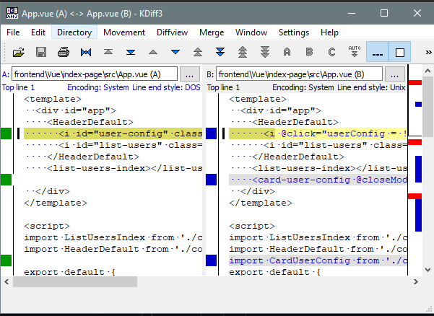

These sites were very helpful, almost, [mergetool](https://git-scm.com/docs/git-mergetool) and [difftool](https://git-scm.com/docs/git-difftool#git-difftool---no-trust-exit-code). I used the global configuration, but can be used by repository without problems. You just need to execute the following commands:

git config --global merge.tool kdiff3

git config --global mergetool.kdiff3.path "C:/Program Files/KDiff3/bin/kdiff3.exe"

git config --global mergetool.kdiff3.trustExitCode false

git config --global diff.guitool kdiff3

git config --global difftool.kdiff3.path "C:/Program Files/KDiff3/bin/kdiff3.exe"

git config --global difftool.kdiff3.trustExitCode false

Note that the latest version kdiff3 moved the executable from the root of the application folder C:/Program Files/KDiff3 into the bin/ folder inside the application folder. If you're using an older version, remove "bin/" from the paths above.

The use of the *trustExitCode* option depends on what you want to do when diff tool returns. From [documentation](https://git-scm.com/docs/git-difftool#git-difftool---no-trust-exit-code):

*git-difftool* invokes a diff tool individually on each file. Errors reported by the diff tool are ignored by default. Use **--trust-exit-code** to make *git-difftool* exit when an invoked diff tool returns a non-zero exit code.